MOCKITO EXERCISES

**Exercise 1: Mocking and Stubbing**

**Scenario:**

You need to test a service that depends on an external API. Use Mockito to mock the external API and stub its methods.

**Steps:**

1. Create a mock object for the external API.

2. Stub the methods to return predefined values.

3. Write a test case that uses the mock object.

**Solution:**

**ExternalApi.java**

package org.example;

public interface ExternalApi {

String getData();

}

**MyService.java**

package org.example;

public class MyService {

private ExternalApi api;

public MyService(ExternalApi api) {

this.api = api;

}

public String fetchData() {

return api.getData();

}

}

**MyServiceTest.java**

package org.example;

import org.junit.jupiter.api.Test;

import static org.mockito.Mockito.*;

import static org.junit.jupiter.api.Assertions.*;

class MyServiceTest {

@Test

void testExternalApi() {

ExternalApi mockApi = mock(ExternalApi.class);

when(mockApi.getData()).thenReturn("Mock Data");

MyService service = new MyService(mockApi);

assertEquals("Mock Data", service.fetchData());

}

}

**Output:**

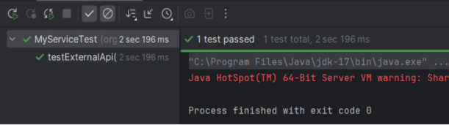

**Exercise 2: Verifying Interactions**

**Scenario:**

You need to ensure that a method is called with specific arguments.

**Steps:**

1. Create a mock object.

2. Call the method with specific arguments.

3. Verify the interaction.

**Solution** :

**ExternalApi.java**

package org.example;

public interface ExternalApi {

String getData();

}

**MyService.java**

package org.example;

public class MyService {

private final ExternalApi api;

public MyService(ExternalApi api) {

this.api = api;

}

public String fetchData() {

return api.getData();

}

}

**MyServiceTest.java**

package org.example;

import org.junit.jupiter.api.Test;

import static org.mockito.Mockito.*;

import static org.junit.jupiter.api.Assertions.*;

class MyServiceTest {

@Test

void testFetchDataReturnsMockValue() {

ExternalApi mockApi = mock(ExternalApi.class);

when(mockApi.getData()).thenReturn("Mock Data");

MyService service = new MyService(mockApi);

String result = service.fetchData();

assertEquals("Mock Data", result);

}

@Test

void testFetchDataCallsExternalApi() {

ExternalApi mockApi = mock(ExternalApi.class);

MyService service = new MyService(mockApi);

service.fetchData();

verify(mockApi).getData();

}

}

Output:

